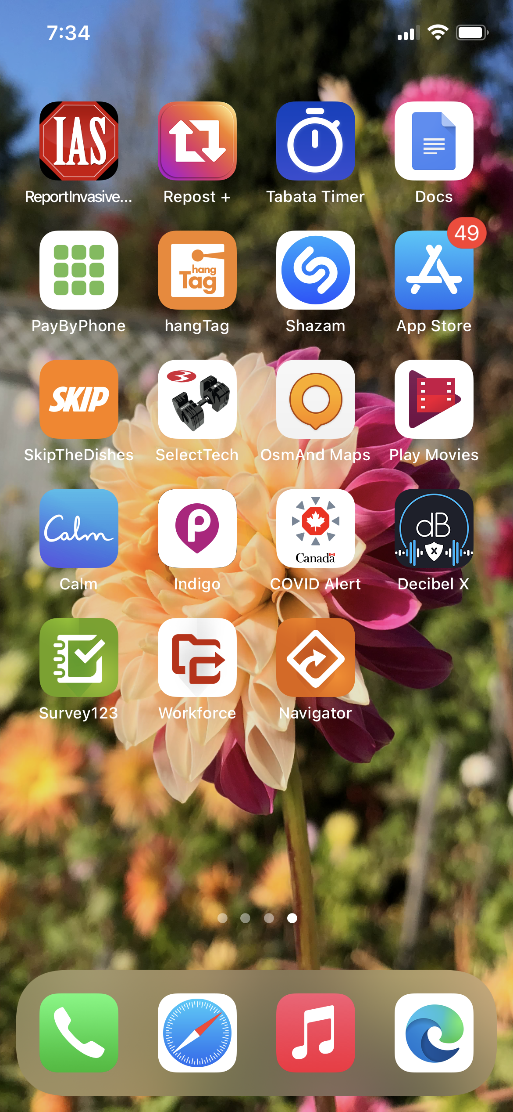  Survey123, WOrkforce, Navigator FIELD USE | AT a Glance  - Basic workflow for trap setup, checks and visual surveys using the software (Section 1)  - View, start, decline and finish assignments in Workforce (Section 2)  - Navigating to assignments (Section 2.3)  - Opening Survey123 and completing setup and check forms (Section 2.4 - 2.6)  - Syncing assignments in Workforce (Section 2.8)  - Using Survey123 without Workforce (Section 3)  - Working out of cell range (Section 4)  - GPS: how and when to capture it and how the Workforce and Survey123 applications interact (Section 5)  - Understanding the Trap check condition status pull down options (Section 6)  - Key steps to follow if you find a suspect in the field (Section 7)  - LSTS and Survey123 Sample Submission (Section 8)

How to use this document
- This self-help document provides you a step-by-step approach to using various features of the Survey123, Workforce, and Navigator applications. It is organized so that you can select the task you would like help with, without having to read through the full document. Please also consult the troubleshooting guides if needed.

Legend related to learning Material Flow:
- Provides general comments about the application.

#. Detailed step in application. The #. will correspond to a particular screen capture following the detailed step.

In the sections below, if there are differences between the iPhone and Samsung, the iPhone image will be highlighted with a red border to denote the difference.

- Basic Workflow
The applications you will be using to receive your work assignments, navigate to survey sites and collect survey information are all interconnected. It is important that you follow the steps below. Please pay careful attention as to when to capture the GPS in the survey form. More details will be provided in this document explaining how the applications interact and when to capture the GPS. For surveys that occur at predetermined sites or have multiple site visits it is recommended to use Workforce to assign and receive work assignments, in combination with Navigator and Survey123. Data can, however be entered directly into Survey123 without the use of the other applications.
Please ensure you have the applications installed on your mobile device and are signed in to each application before proceeding See: ESRI Mobile Software Setup document RDIMS # 14691031 (ENG) / 14721080 (FR).

  - Overview of Trap Setup, Trap Check and Visual Surveys on Mobile phones using the ESRI applications

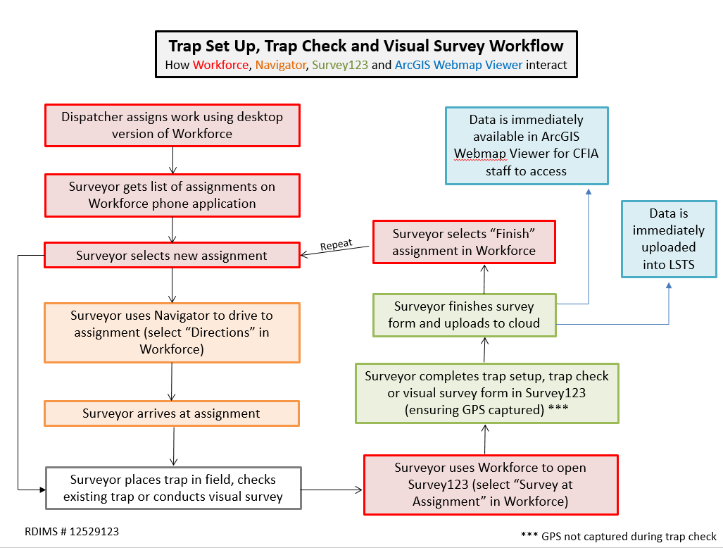
  - Overview of Trap Setup, Trap Check and Visual Surveys on Mobile phones using the ESRI applications without Workforce
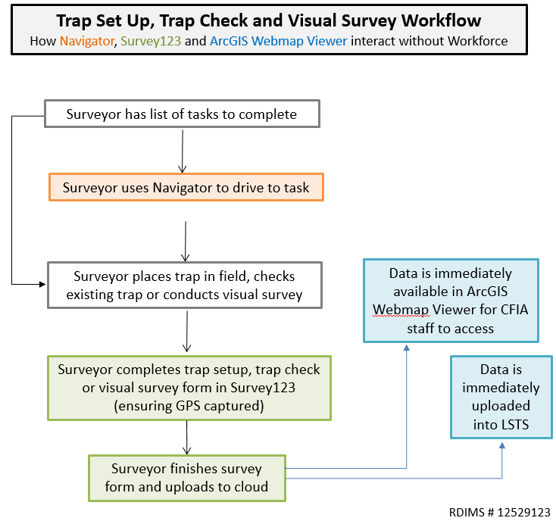

- Workforce Based Surveys

This section will cover the use of all three applications - Workforce, Navigator and Survey123 - to conduct plant health surveys. The applications work best when all three software are used together. Workforce allows survey activities to be dispatched, assigned and tracked in real time. It also provides surveyors with access to previously collected site information (trap setup, host, trap barcode, photo, etc.) or proposed survey site location details information (e.g. Asian longhorned beetle grid id # etc.). See section 3 for details on collecting data without using Workforce.

  - Viewing Assignments in Workforce
- Login to Workforce.
- Select and download (if not already done) the map you would like to work on; this is where your survey assignments are stored.
e.g. Gypsy moth trap setup, Japanese beetle trap setup
- Survey assignments can be sorted by date, distance (relative to your current location), assignment type (municipality, surveyor name) and priority (low, medium, high, critical) by selecting the Sort icon.

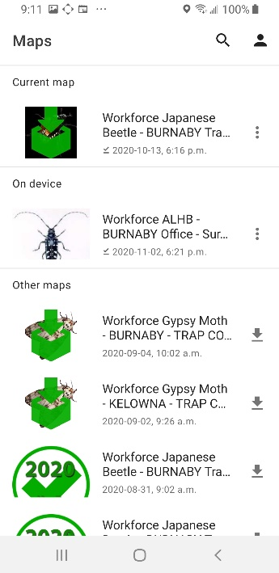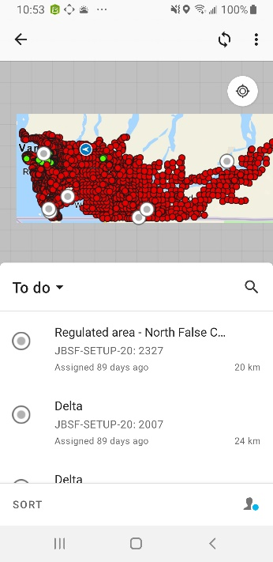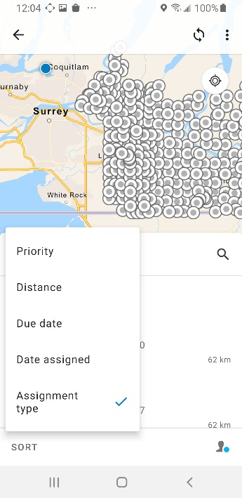
3..
3..
2..

- Use the magnifying glass and search bar to filter the assignment type and map e.g. City of Langley. The number of assignments in the area will be displayed next to the city/assignment type.
- Specific details or instructions provided by the dispatcher may appear in the Description field.
Workforce survey maps often grey-out areas outside of the selected surveillance area to facilitate offline working when there is no cellular service.

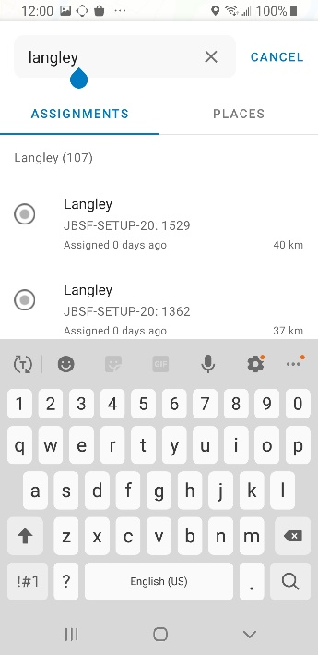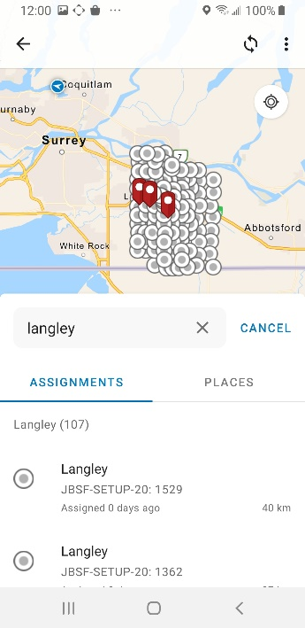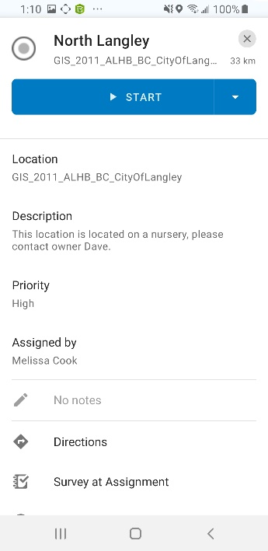
5..
4..
4..
4..

- The “person” icon can be used to indicate your working status. When you change your working status to “on break” or “not working” your location is not collected and will show as your last known location. It is recommended that you change your working status to “not working” or log out after you finish your assignments for the day.

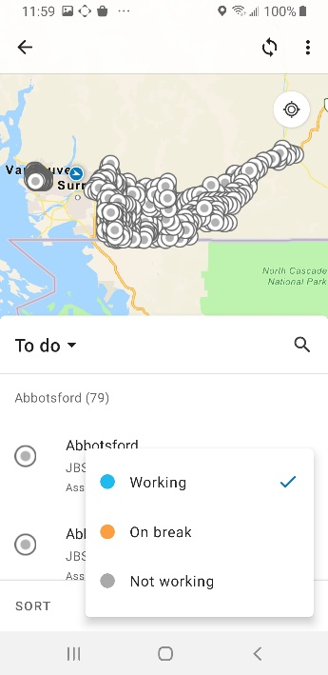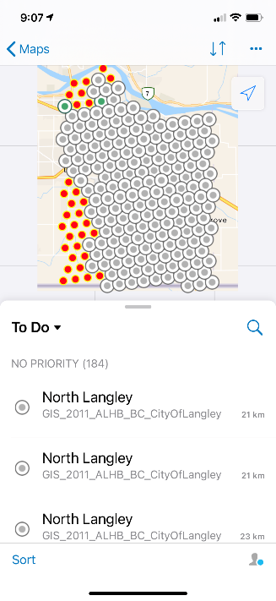
6&7.
7..
6..

- Pressing the three “vertical” (Samsung) or “horizontal” dots (iPhone) will display layers and legend options. The layers option displays the work assignments (grey circles) and the trap setup or proposed survey site information (red circles).

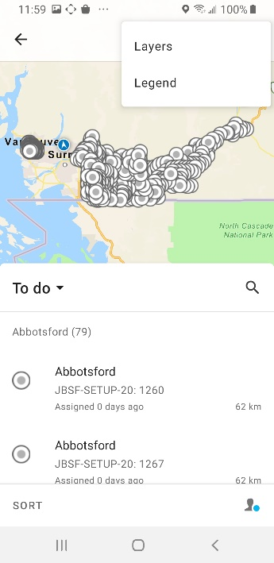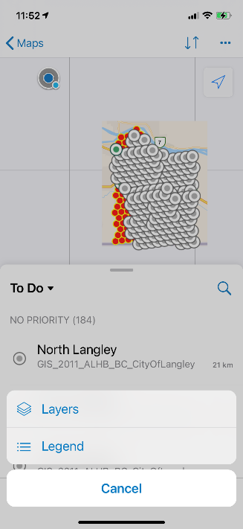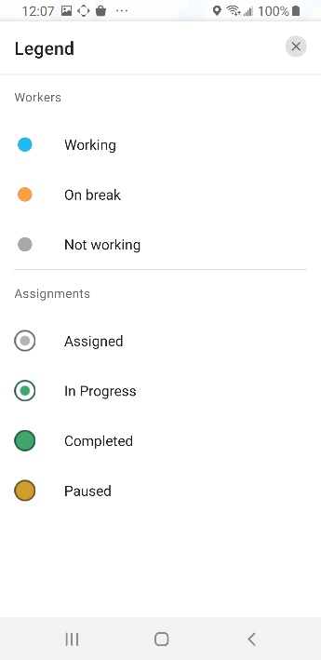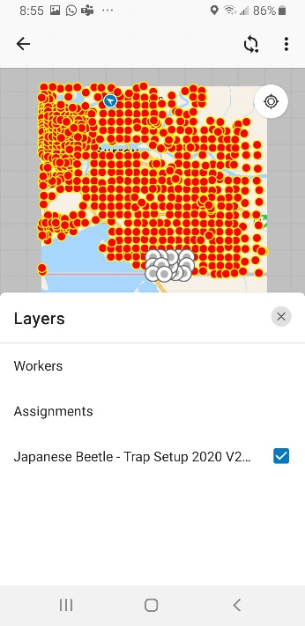
7..
7..
7..
7..

**** Note: Workforce only shows your location while the app is in use. Your location and routes are not collected.
  - Starting Assignments in Workforce
- Assignments to be completed are displayed in grey circles on the map.
- Your current location is displayed as a solid dark blue circle .
- To make the map full screen touch the “To Do” icon and swipe downward. You can zoom in or out of the interactive map placing two fingers on the map and moving them apart/closer.

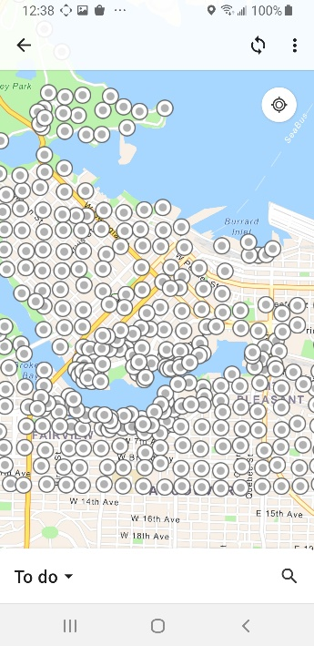
1-3.
1-3.

- In order to see the assignments’ details, select the appropriate assignment from the list; the assignment will be highlighted in turquoise.
- If you selected an assignment from the map by touching a grey circle, a box will appear with “2 Items”. Select the corresponding assignment (grey circle) from the layer list.
- Touch and swipe upward to make the assignment details field go full screen.
- Use the “X” icon to unselect the assignment or select another assignment on the map by selecting/touching the assignment and the new details will appear.

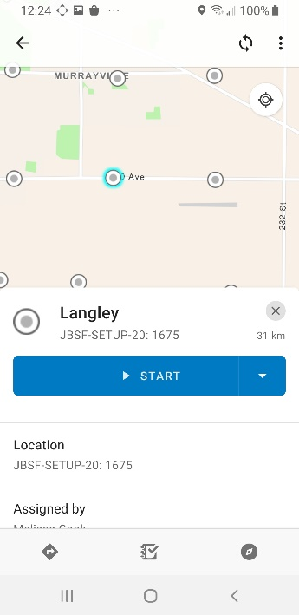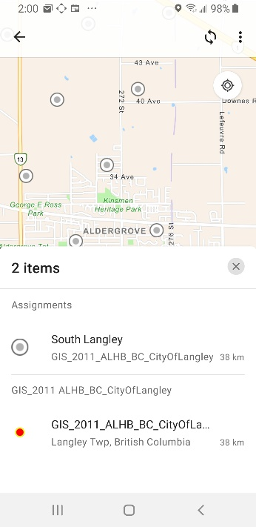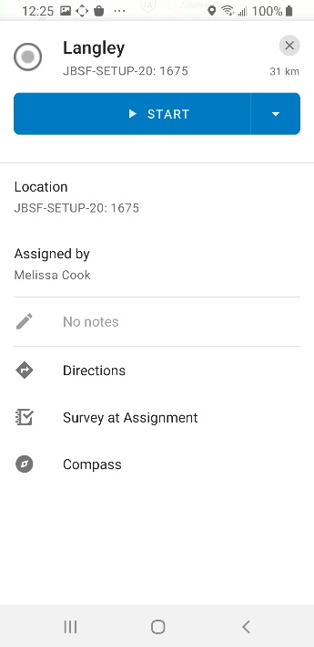
4..
5.
6.
6&7.
****Note: If you selected the wrong Workforce map you can go back to the map list by selecting the left pointing “arrow” (Samsung) or “Maps” (iPhone) on the top left corner and then select the appropriate map you would like to work on e.g. Gypsy moth trap setup instead of Japanese beetle trap setup

- Start your assignment by selecting “START” or the “down arrow” (Samsung) or “three parallel dots” (iPhone).

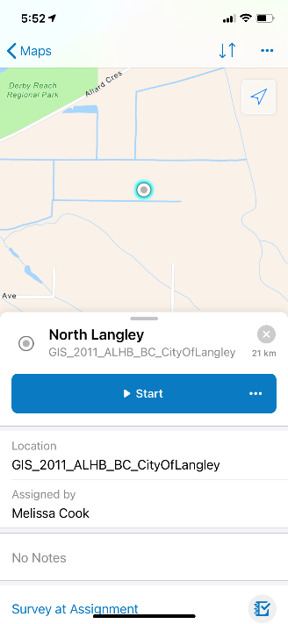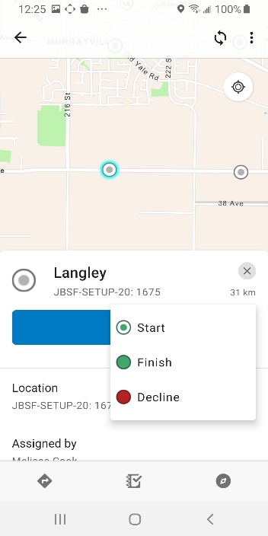
8..
8..
8..

- The assignment status can be reset by selecting the “down arrow” (Samsung) or “three parallel dots” (iPhone) icons and then selecting “Reset” (see Survey123 troubleshooting document RDIMS#14705207 for details on how to reset a Finished/Completed work assignment).
- An assignment can also be “Declined”, a popup will occur asking you to explain why e.g. can’t access site due to construction, fence around trap.

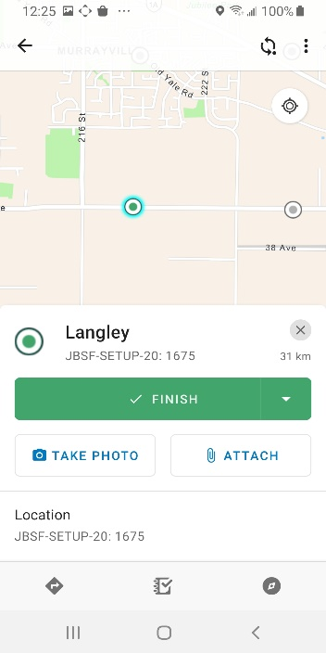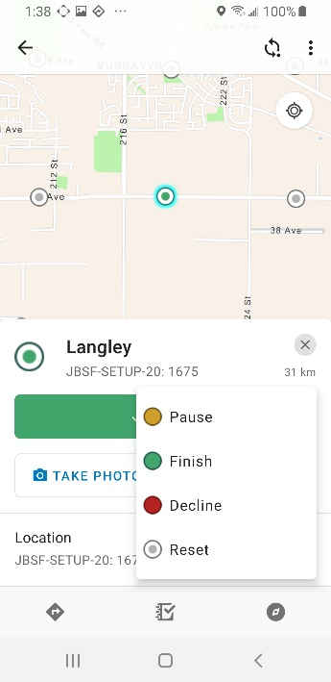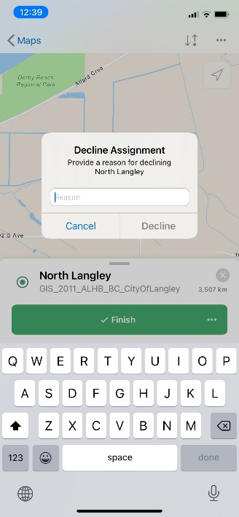
10..
9&10..
9..
**** Note: the numbers used in Workforce to identify work assignments change in every project and are NOT the trap’s barcode. DO NOT use the Workforce assignment #’s to make the trap barcode or the grid ID points for the Visual Surveys unless the assignment clearly indicates “Trap Barcode: SURVEY-PROVINCE-2021-XXXX”

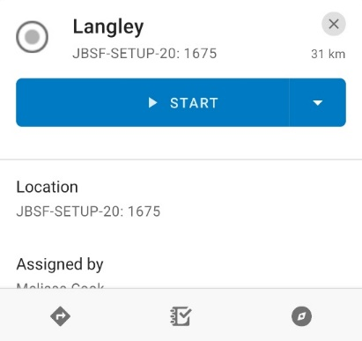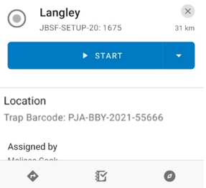

  - Navigating to Assignments in Workforce
- To navigate to your assignment select “Directions” (Samsung) or “Navigate to Assignment” (iPhone). Then select a navigational tool to navigate to your assignment: Navigator application (download map prior to use to prevent error message), Google Maps or Apple Maps (only on iPhone).
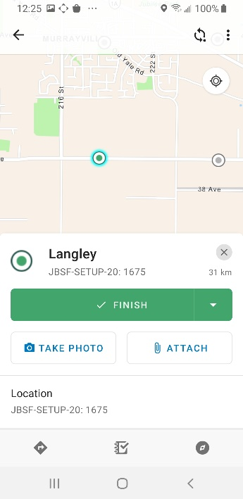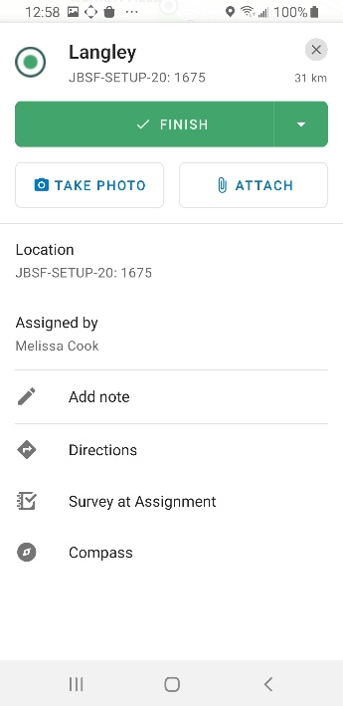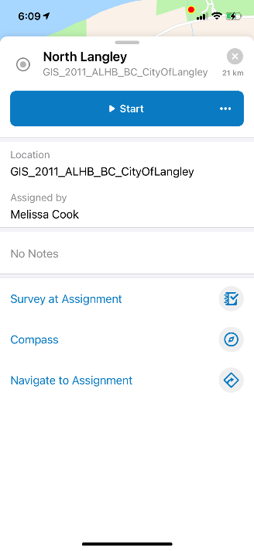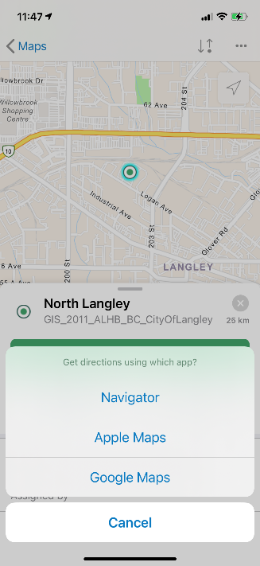
1.
1.
1.
1.

- Shortcut icons in the Workforce application are available for Directions, Survey123 and Compass. The symbology and organization of the shortcut icons differ slightly between Samsung and iPhone.

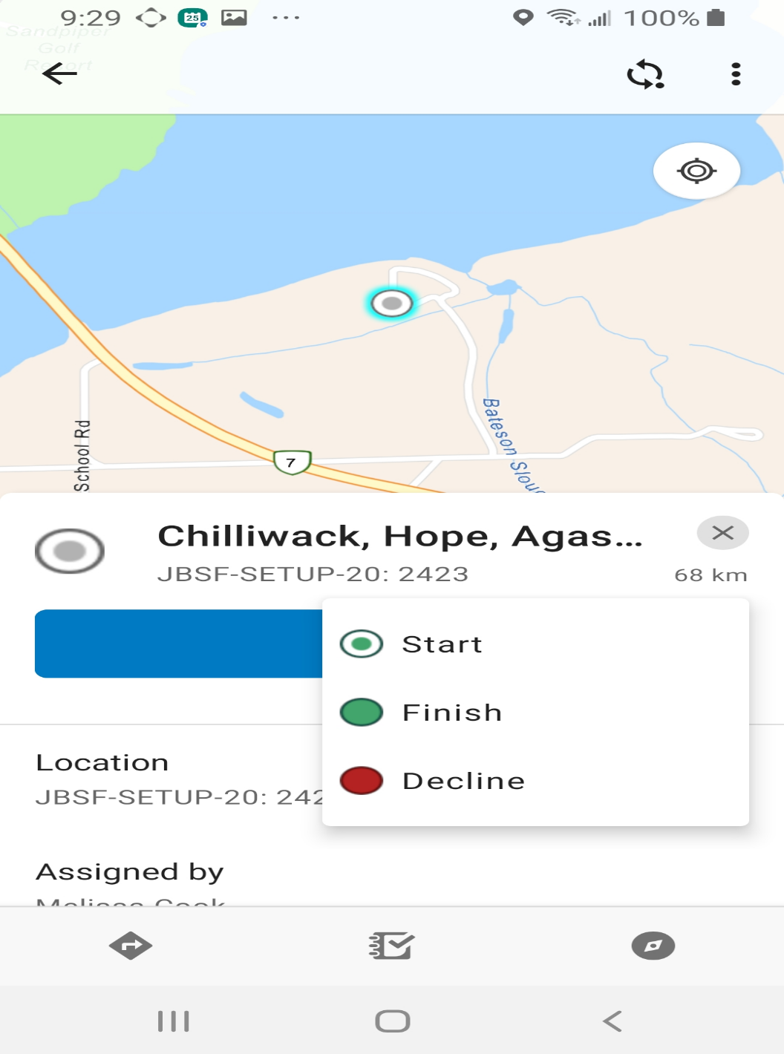
Samsung
Navigate Survey123 Compass

2.

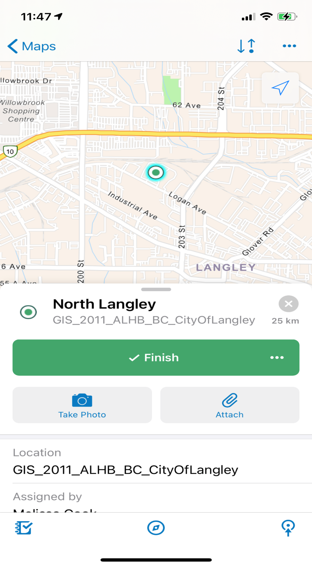
Survey123 Compass Navigate

iPhone

2.
**** Note: It is important to stay aware of road conditions and signs, as Navigator and Google Maps may not have access to up to date information such as road closures and changes. You are still responsible for your safety while driving.

Navigator Application
- Navigator will automatically calculate the route to this assignment relative to your current location.
- Select “GO” and the phone will verbally navigate you to the location.
  - Select “OK” (Samsung)/ “Accept” (iPhone) on the safety warning.
  - Don’t show this safety message again can be selected from here.
- Once you’ve arrived at the location a pop up will ask if you would like to return to Workforce; select “RETURN”. If you do not receive this popup use the “back” or “recent pages” icons (Samsung) or “home” icon (iPhone) to return to Workforce.
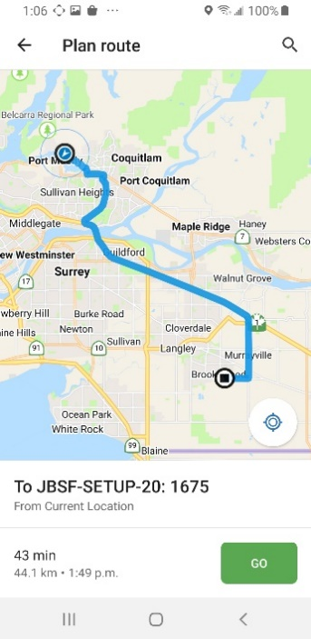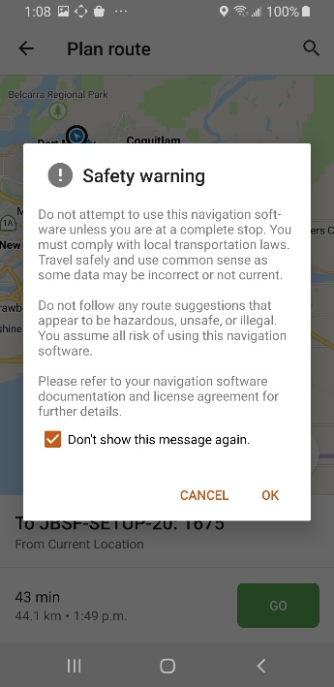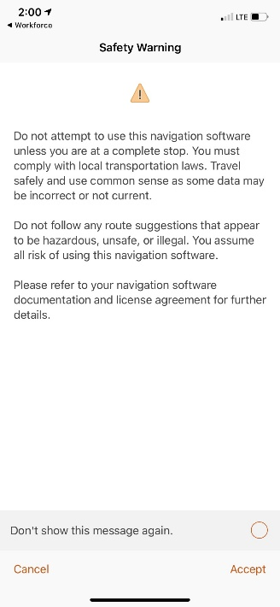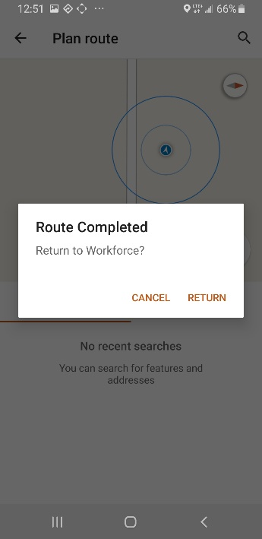
3.
2a&b.
2a&b.
1&2.

Google/Apple Maps
- Google maps will automatically calculate the route to this assignment relative to your current location.
- Select “Start” (Google Maps) or “GO” (Apple maps) and the phone will verbally navigate you to the location.
- Once you’ve arrived at the location select the “back arrow” (Samsung) or “black bar” (iPhone) to close Google Maps and then select Workforce so that you can start the assignment in Survey123.

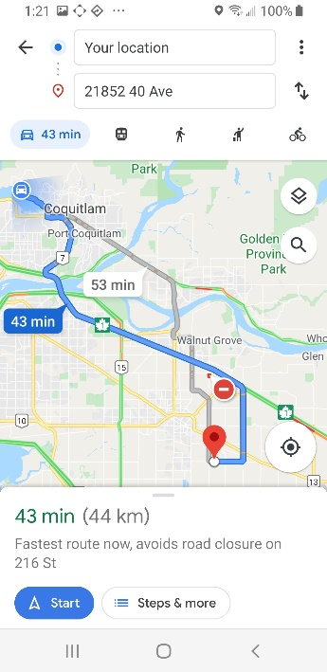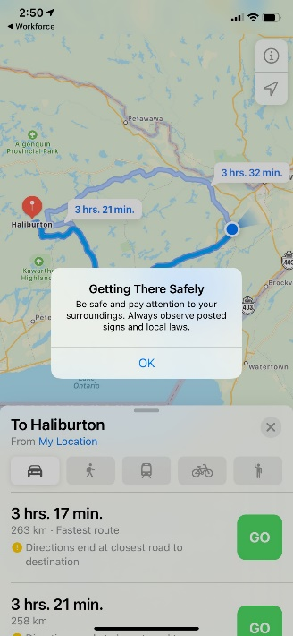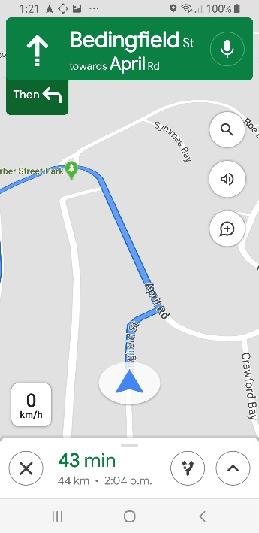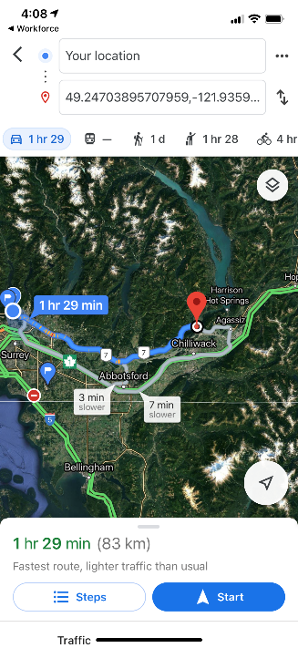

3.

3.
1&2.
1&2.

  - Opening the Survey123 application using Workforce
- Ready to start your assignment and collect data? Select the Survey123 shortcut icon or “Survey at Assignment” in Workforce.
  - Selecting “Survey at Assignment” will automatically open Survey123 and the appropriate survey form.
  - If you have not downloaded the survey form, Survey123 will automatically initiate form download.
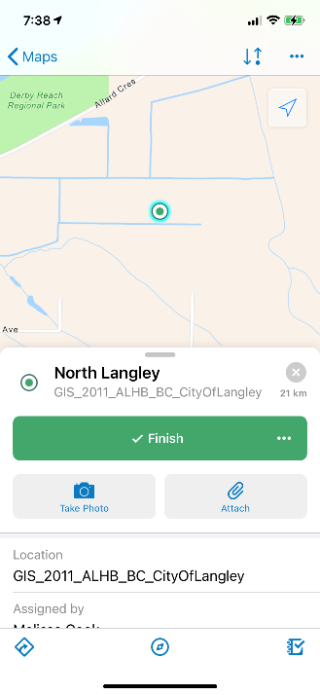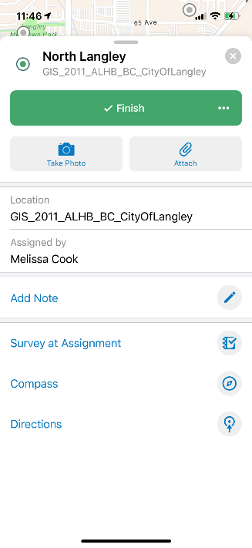
1.
1.
1.
1.

  - Completing a Survey123 form trap setup form
- Survey123 trap setup and visual survey forms are organized into two main areas of data collection: “Surveyor Information” and “Site Information”. Select the “arrow” icon to expand each section.
- Fields with * are mandatory and must be completed for a form to be uploaded; if not completed, the section will be highlighted in a red box.
- Refer to survey protocol for specific data entry details.
- The date will prepopulate into the form.
- Using the drop down menus select your “Province” and “Office Location”. Then select your name from the “Surveyor” menu. If the phone keyboard appears use the “down arrow” (Samsung) or “done” (iPhone) to minimize it.

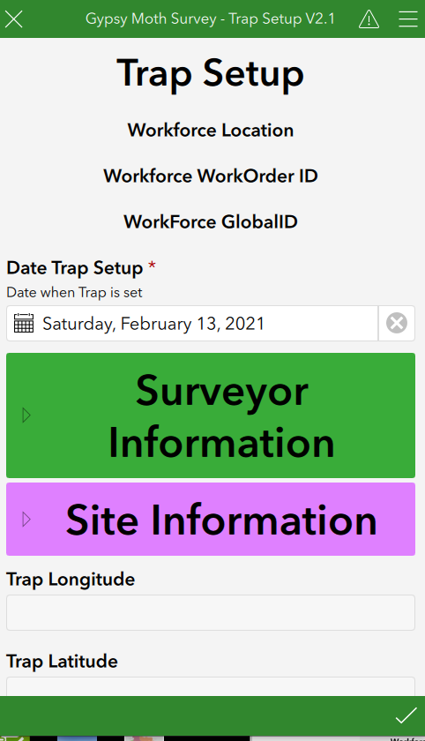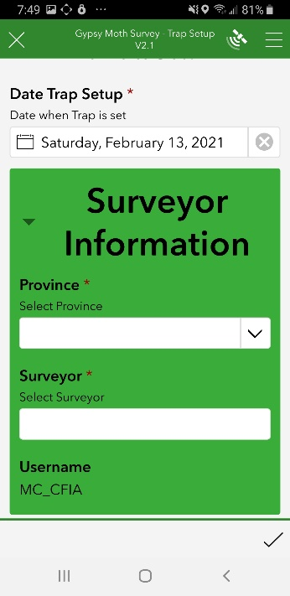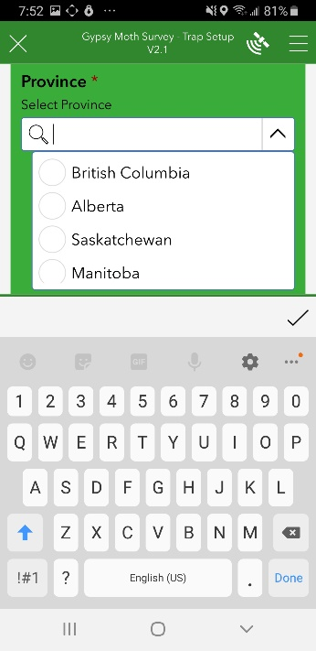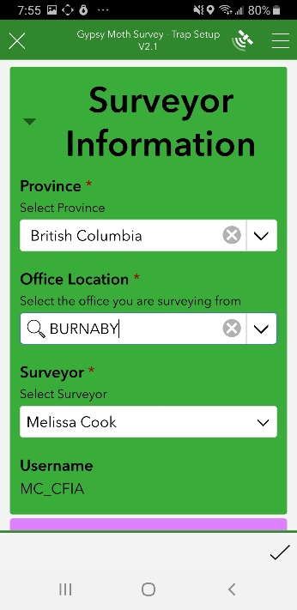
3.
3.
2&3.
1.

- In the “Site Information” section, select the “Crosshairs icon” or “Map” to focus the GPS and geocode the survey site address. See section 5 for more information on GPS capturing.
- The “Survey Site Address” and “Survey Site Municipality” fields can be edited if the provided address is not accurate or complete.
- If necessary use the “Directions to Trap Location” field to provide additional instructions to help in finding the survey site.
- Enter your “Site Type” and “Trap Type”. These fields are key for helping the lab to determine what Gypsy moth traps require genotyping.
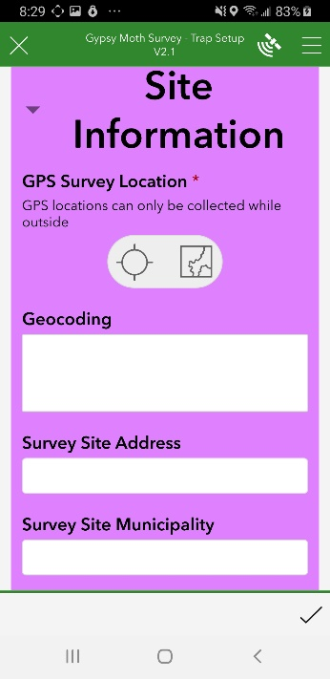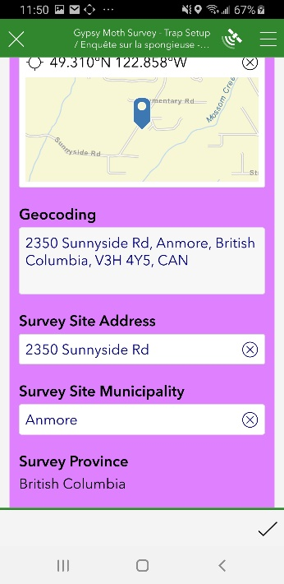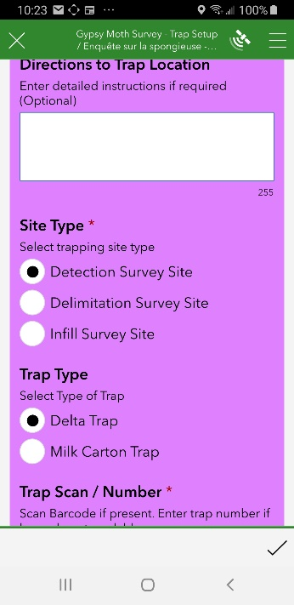
7.
6.
4&5.

4.
- Scan the barcode with your phone by touching the “QRL” icon. Confirm the barcode in the form matches the number on the barcode label. Scanning may require you to hold your camera at different angles, depending on sunlight and other outdoor factors. You can also type the 5 digit code if there are barcode scanning issues.
- This will complete the trap barcode LDA-BC-2021-XXXX
- Select a host from the “Host” menu. To sort the list type the name of the plant genus.
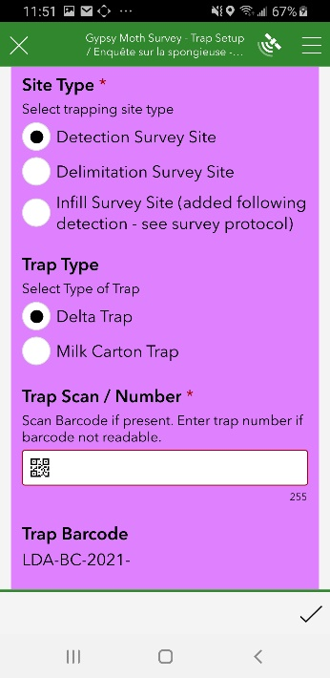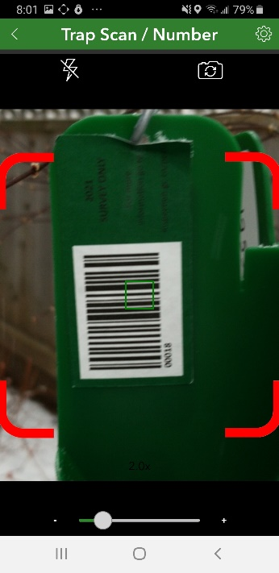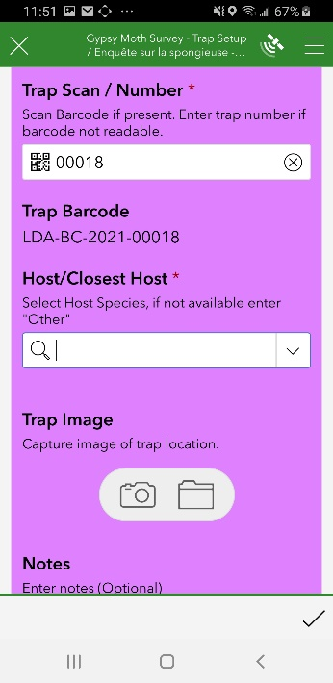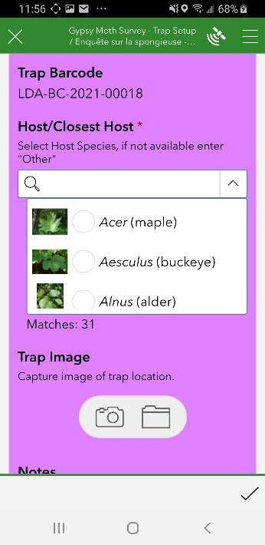

8.
**** Note: The trap barcode (e.g. LDA-BC-2021-00004) links all of the data together for a particular survey site from setup, through all of the trap checks and finally collection. Any changes to the trap barcode will cause problems when the data is uploaded into the LSTS!

10.
9.
8.
- Select the “Camera” icon to take a picture of the trap and its surroundings or use the “folder” icon to upload a image from your phone’s gallery. In the photo capture unique features or landmarks that surround the trap to help in locating the trap.
- The photo can be deleted or select the “three horizontal” dot icon for more options.
- Additional notes about the trap can also added to the “Notes” field.

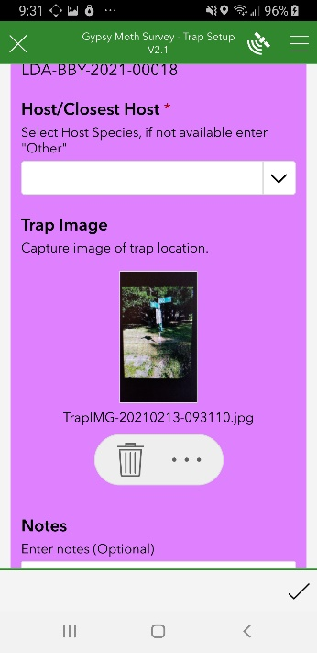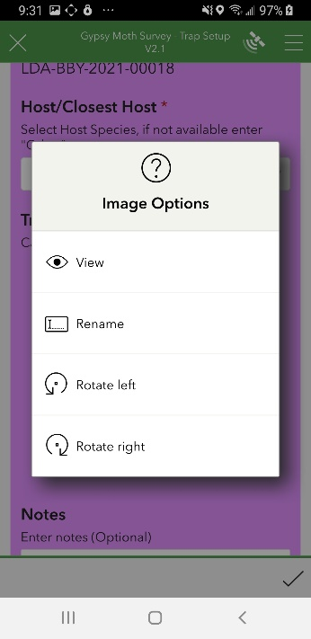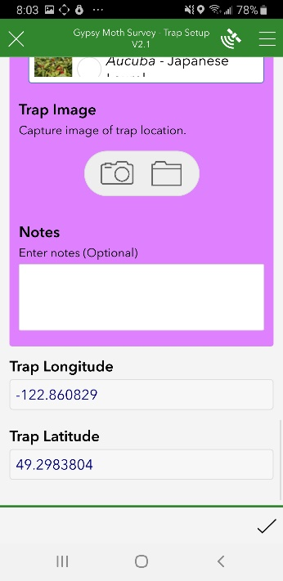

11.
11&12.
13.
11&12.

- Select the “check mark” and “Send now” to upload the form.
- Use the “recent pages” icon (Samsung) or “home” icon (iPhone) to display all of the applications you have used then select Workforce to return to the assignment.
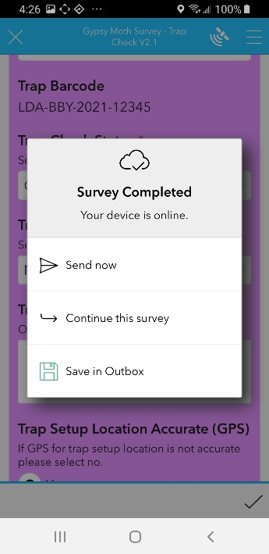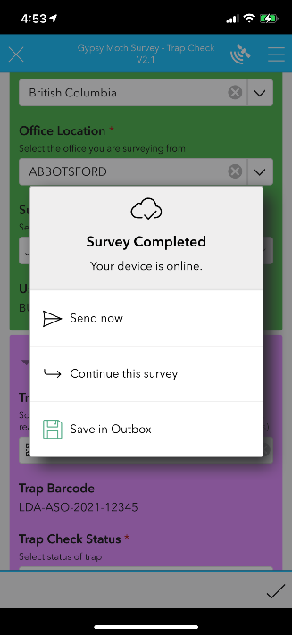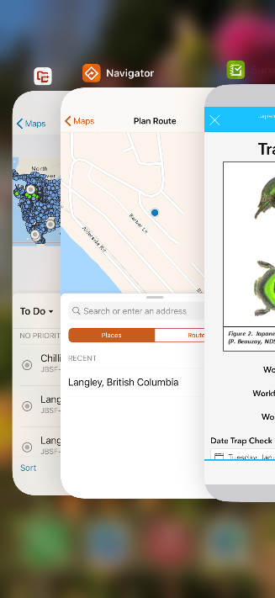
15.
15.
14.
14&15.

  - Completing a Survey123 trap check form
- Survey123 trap check forms are organized into two main areas of data collection “Surveyor Information” and “Site Information”. Select the “arrow” icon to expand each section.
- Fields with * are mandatory and must be completed for a form to be uploaded; if not, the incomplete section will be highlighted in a red box.
- Each survey protocol will have an appendix with detailed information on what information to capture in the survey form.
- The date will prepopulate into the form.
- Using the drop down menus select your “Province” and “Office Location”. Then select your name from the “Surveyor” menu. If the phone keyboard appears use the “down arrow” (Samsung) or “done” (iPhone) to minimize it.

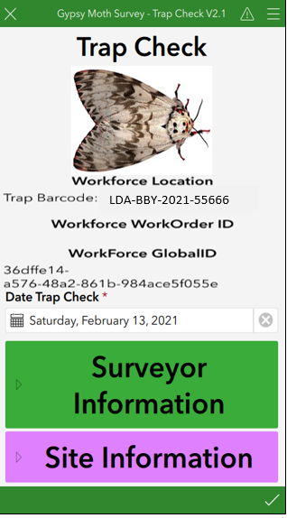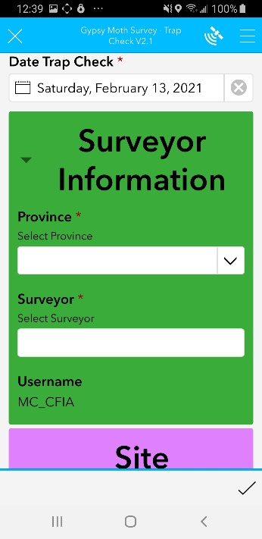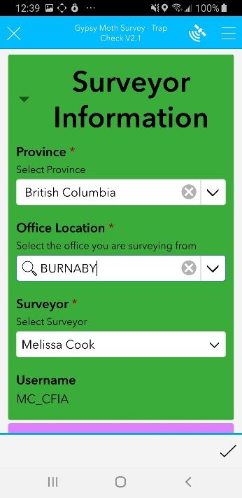
1.
1&2.
3.
3.

- Scan the barcode with your phone by touching the “QRL” icon. Confirm the barcode in the form matches the number on the barcode label on the trap. You can also type the 5 digit code if there are barcode scanning issues, the trap is missing or damaged.
- This will complete the trap barcode LDA-XX-2021-XXXX. Select the appropriate “Trap Check Status” and “Trap Check Condition Status” pull downs (see section 6 for details on how to correctly complete these fields).
- Select the appropriate “Trap Result” (see section 6 for additional details)
- Select Yes or No if “Trap collected for Season” (Yes- applies to traps removed from field i.e. due to theft and traps collected at end of survey season).
- Enter any additional information in the “Trap Check Notes” field.

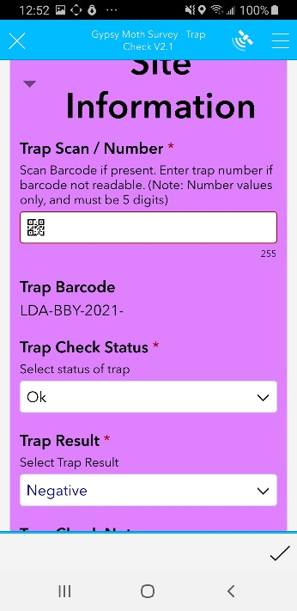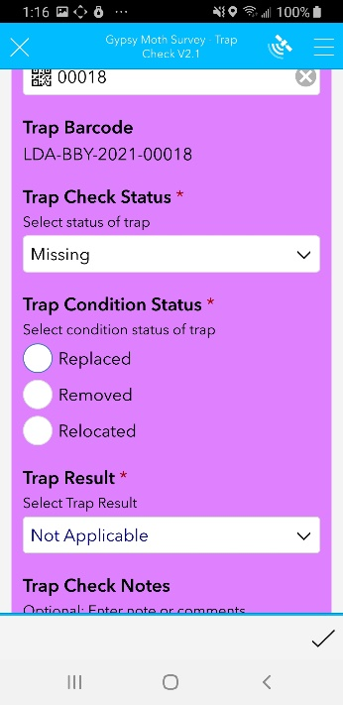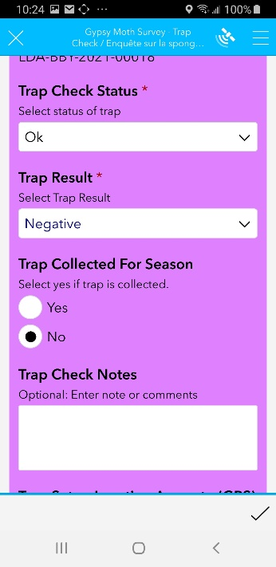
4.
4.
5&6.

7-9.
**** Note: The trap barcode (e.g. LDA-BC-2021-00004) links all of the data together for a particular trap from setup, through all of the trap checks and finally collection. Any changes to the trap barcode will cause problems when the data is uploaded into LSTS!

- Next select Yes or No if the “Trap Setup Location Accurate (GPS)”.
- If Workforce did not take you to the exact location of the trap select “NO” and recapture the GPS by selecting the “Crosshairs”. All subsequent visits to the site will be directed to the updated GPS location.

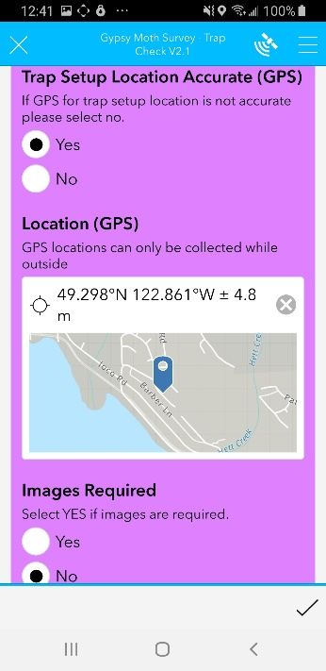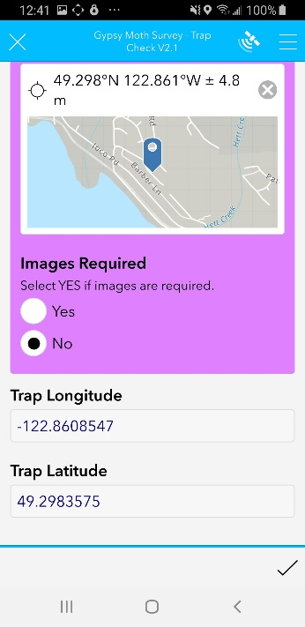
11.
10.

- Next select Yes “Images Required” if suspect(s) are found. A new field will appear allowing up to three high resolution images to be taken.
- Select the “Camera” icon to take the images or use the “Folder” icon to upload a images from your phone’s gallery. Take a close up and distant image of the suspect(s). Ensure the images are in focus.
- The photos can be deleted or select the “three horizontal” dot icon for more options.

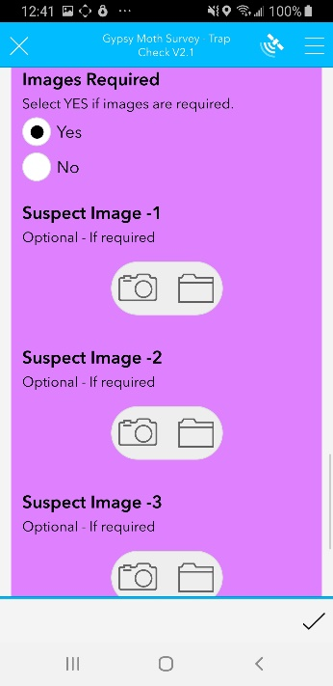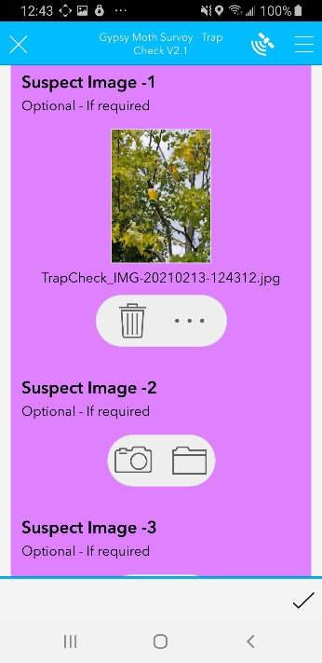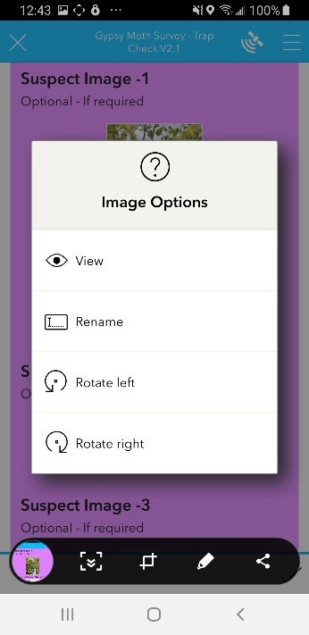
12&13.
13&14.
13&14.

- Select the “check mark” and “Send now” to upload the form.
- Use the “recent pages” icon (Samsung) or “home” icon (iPhone) to display all of the applications you have used then select Workforce to return to the assignment.
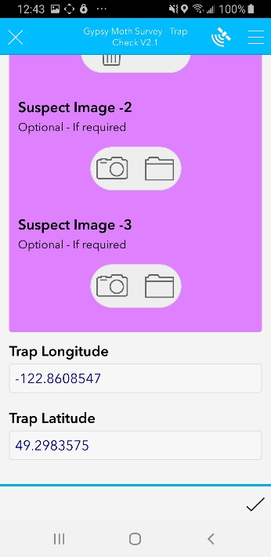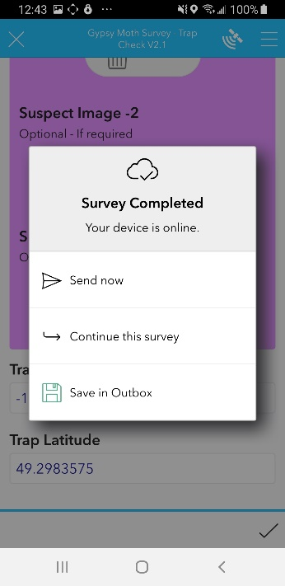
15&16.
15&16.
15&16.

15&16.
  - Finishing Workforce Assignments
- Once back in Workforce select “FINISH” or the “down arrow” icon (Samsung) or “three dot” icon (iPhone) to complete your assignment.
- The assignment will disappear from the “To Do” list and the map.

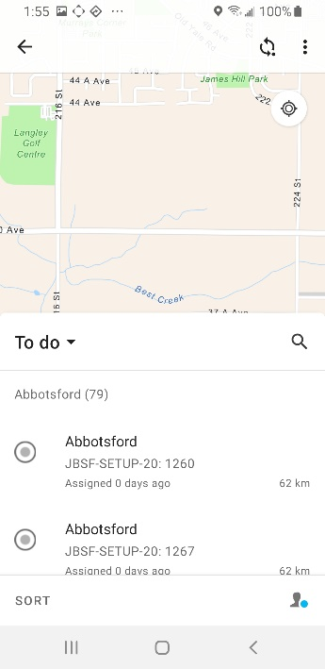
2.
1.
1.
1.

- To view completed assignments select “To Do” and then select “Completed”. A new list and map will appear showing your completed assignments. See Workforce troubleshooting RDIMS #14705195 for how to reset completed assignments.
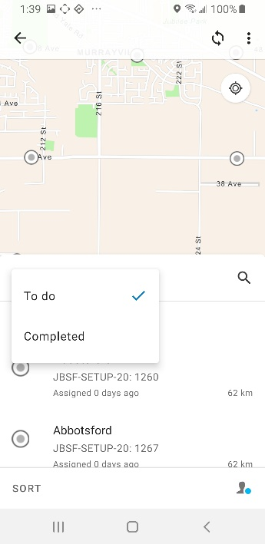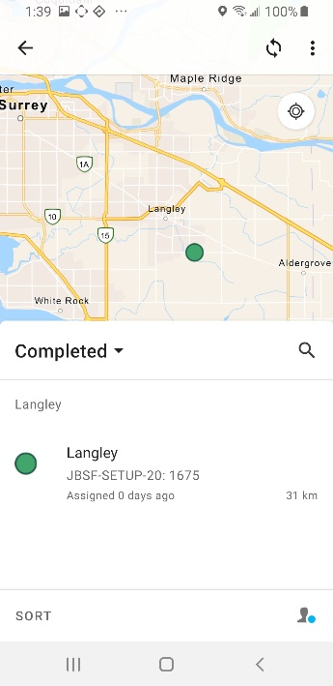
3.
3.
3.

  - Syncing Workforce Assignments
- Workforce will work offline in areas where there is limited cellular connection
- Sync allows you to send and receive updated assignments either on demand or automaticaly every 15 minutes while in cell range.
- When the application is actively in use, Sync occurs every 1min.
- A good rule is to check the sync folder at the end or beginning of each day to ensure sync was successful.
- When a period is displayed in the sync icon, there are assignments saved to the Workforce application that need to be uploaded.
- You can also manually sync by selecting the “Sync Now” icon.
- Please leave the Auto-sync “ON” for every 15mins.
- Sync’ed assignments will disappear from the “Items to Update” list and the period will disappear form the sync icon.
**** Note: Sync does not affect the uploading of Survey123 forms

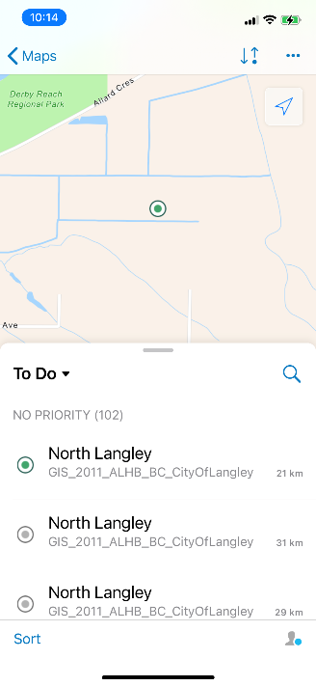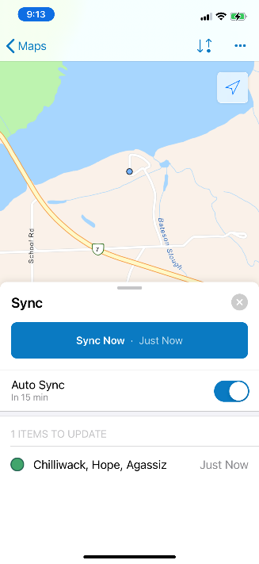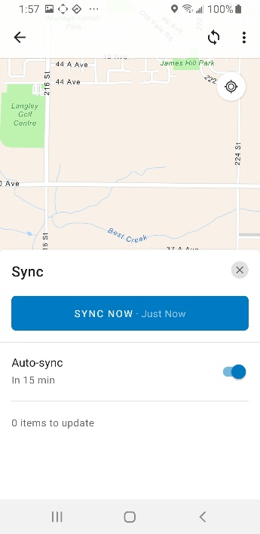
2&3.

4.
1.
1.

  - Accessing Trap setup or Proposed survey site information in Workforce

Workforce utilizes a feature called layers. Knowing how to use this feature is critical. The layers option allows you to see the work assignments (grey circles) and the trap setup or proposed survey site information (red circles). The trap setup information (e.g. host, photo and address) is very useful during trap checking for finding traps, especially if the trap setup GPS was inaccurate.

- Select the three “vertical” (Samsung) and “horizontal” dots (iPhone) to display the “layers and legend”. Select the “Layers” icon.
- Ensure the Trap setup or proposed survey site layer is turned on (blue check mark).
- The assignment layer will always sit on top of the trap setup/proposed survey site layer.

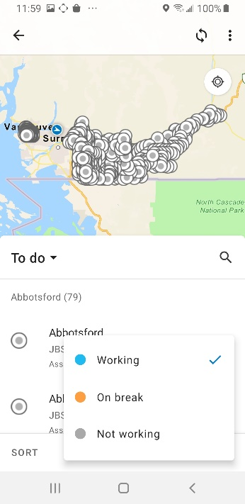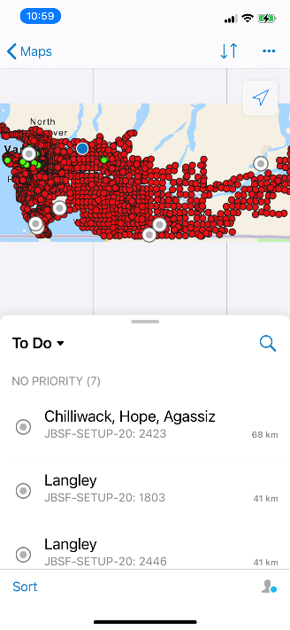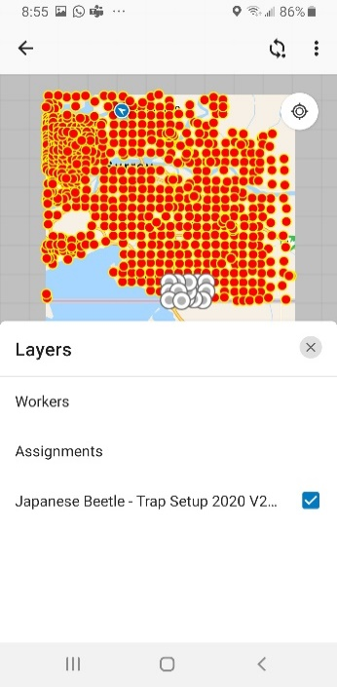

1.
1.
2.
1.

- Select an assignment list from the map or the “To do” list; the trap will be highlighted in turquoise.
- Select the assignment again to display the layers associated with the location.
- Select the “red dot” (trap setup or proposed survey site, depending on the survey), to display all of the trap setup information. For surveys such as the Asian longhorned beetle a grid # is used for each survey site, this information is stored in the proposed survey site layer.
- To view the trap setup photo select “Attached” and then select the image to enlarge the photo.

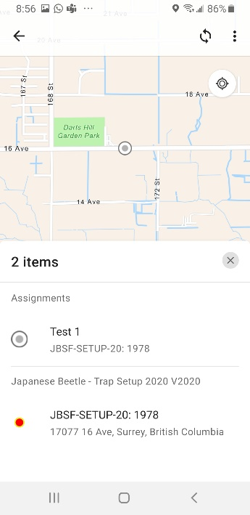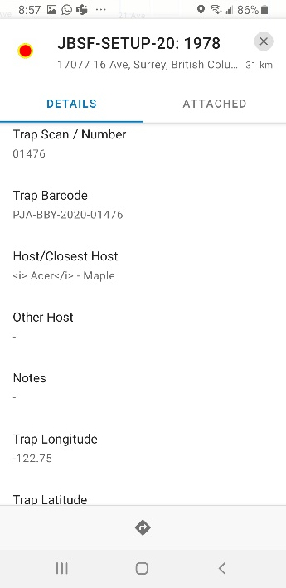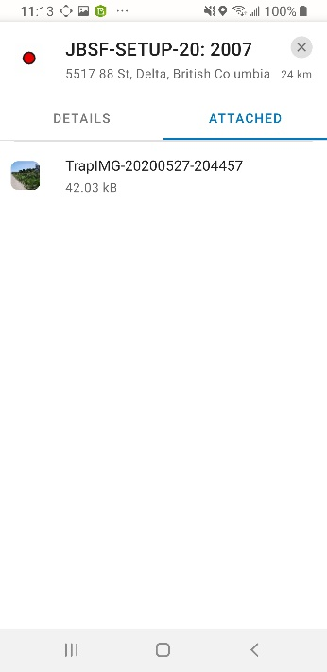
4.
6.
5&6.

3.

- Using Survey123 without the Workforce application

For surveys that do not occur at predetermined sites or do not have multiple site visits, data can be entered directly into Survey123 without the use of the other applications such as Workforce. Not using Workforce will change how you use Survey123 because the two applications are interconnected. You will need to be very diligent in capturing the GPS each time a survey form is completed. Not using Workforce will impact how the data is plotted spatially in the Webmap.
***Note: The Pest inquiry forms is intended to be used without the Workforce application.

  - Completing a Survey123 form
- Log into Survey123 and open the appropriate Survey123 form.
- Next select “Collect” to open the Survey123 form to start collecting data.
- Please see section 2.5 (trap setup and visual survey forms) and section 2.6 (trap check form) for how to complete the forms.
- You MUST Capture the GPS each time when not using Workforce - ensure you are standing next to the survey site or trap you are servicing.
- Select the “check mark” and “Send now” to upload the form.
- Once the form has been upload you will be returned to main page for the form, select “Collect” when you are ready to collect new data at the next survey site.

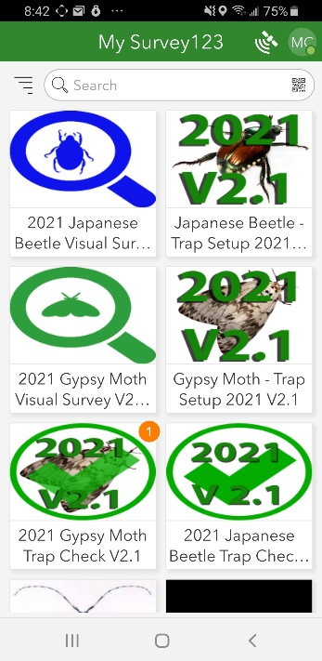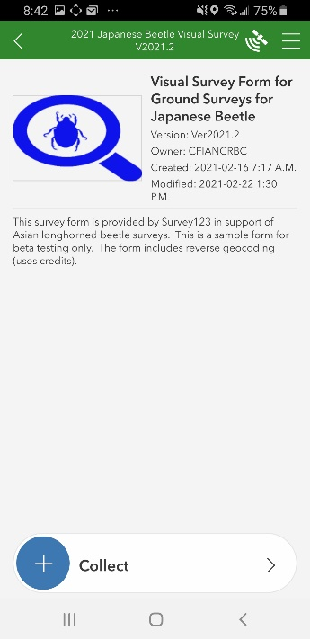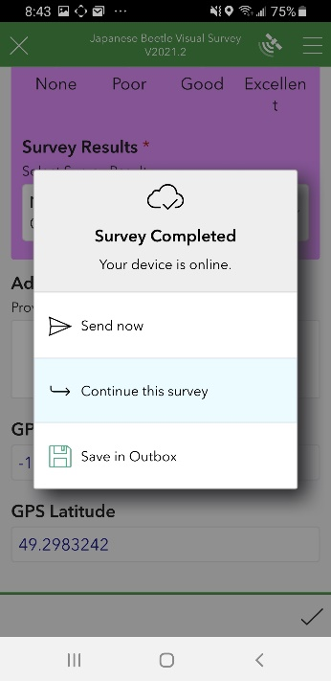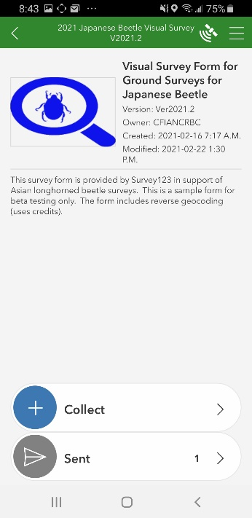
2.
4.
3.

1.

- Working Offline (no Cellular service)

  - Navigator and Workforce applications

- Both applications work in areas of poor or no cellular service however GPS accuracy may be low . Maps are downloaded to Navigator and Workforce so that you can view assignments and get directions when out of cell service.
- Ensure at the beginning of the day that your assignments have been download to Workforce before heading out. This must be completed while in cell range.
- Once back in cellular service data on Workforce can be uploaded “sync’d”.
- Please see Syncing Workforce assignments (section 2.7) for more information.
*** Note: Workforce survey maps often grey-out areas outside of the surveillance area you are working in to facilitate offline working by reducing the size of the map that is downloaded

  - Survey123 application
- Survey123 works in areas where there is limited or no cellular service by saving data captured in the forms locally to the Survey123 application “Outbox”.
- During form upload a pop up will appear indicating whether your device is “Online” or “Offline”.
- If your device is “Online” you can select “Send now” for completed forms or “Save in Outbox” for incomplete forms, allowing you to work on the form at a later time.
- If your device is “Offline” you are out of cell service, the form will automatically be sent to the “Outbox”.
- After the form has been saved to the outbox, exit the form and finish the assignment in Workforce.
- Completed surveys saved to outbox will have a number in the MySurvey123 home screen to indicate the number of completed forms to be sent.
- Once you are in cell service the survey forms can be uploaded by selecting the appropriate survey, then select ‘Outbox’ and select the “Send” icon.

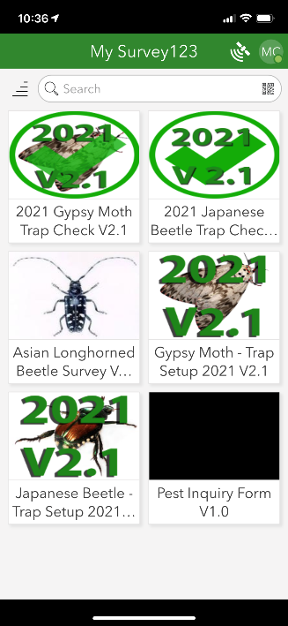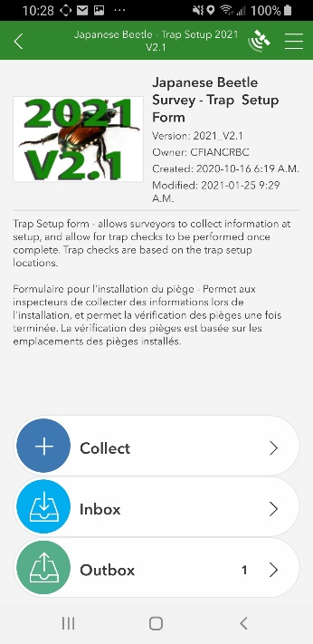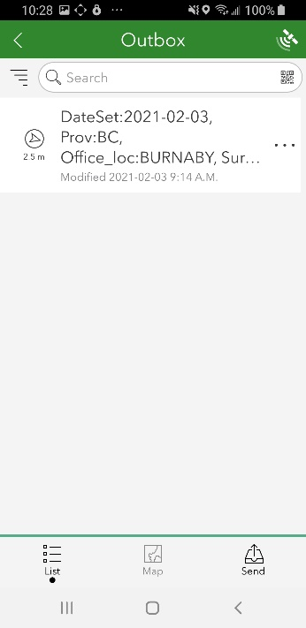
4.
1&2.
3&4.
4.

1

- GPS When and How to Capture it
The flowchart below highlights the key differences Workforce and non-Workforce based surveys. Please ensure you understand the diagram below. Not following these steps impacts how data appears in the Webmap i.e. a detection could appear in the wrong location!
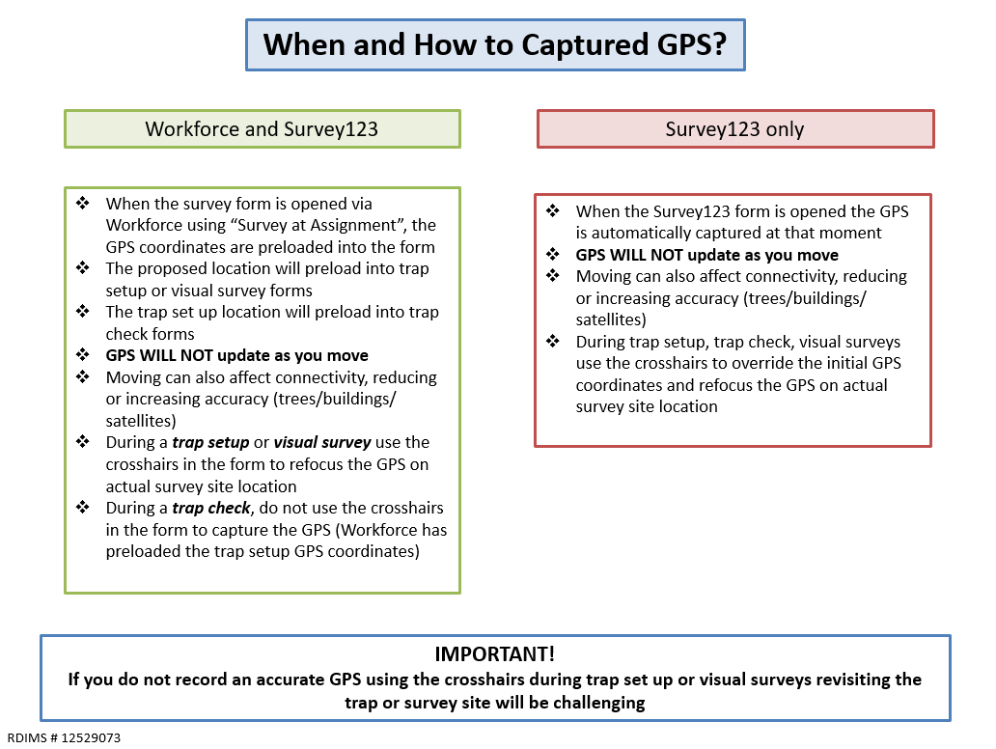

  - Increasing Phone GPS Accuracy
Samsung Phones:
- Select “Settings” in the phone menu
- Select “Connections”
- Select “Location”
- Select “Improve accuracy”
- Turn on Wi-Fi and Bluetooth Scanning

iPhone:
1) Select “Settings”
2) Select “Privacy”
3) Select “Location Services”- ensure location services is “ON”
- Select “Settings”
- Ensure “Wi-Fi” and “Bluetooth” are “ON”

  - Capturing GPS in Survey123 forms
Crosshairs

- Select the “crosshair” icon to focus the GPS on the survey site.
- Selecting the “X” icon will clear all GPS data from the form.
- An acceptable GPS reading is less than +/-10m.
- GPS accuracy is impacted by numerous factors including time of day (number of overhead satellites), buildings, forest cover, network connectivity issues and weather.
- Often waiting a few minutes for more satellites to pass overhead will resolve the issue.
- Selecting the crosshairs will also calculate the Geocoding field for the site address.

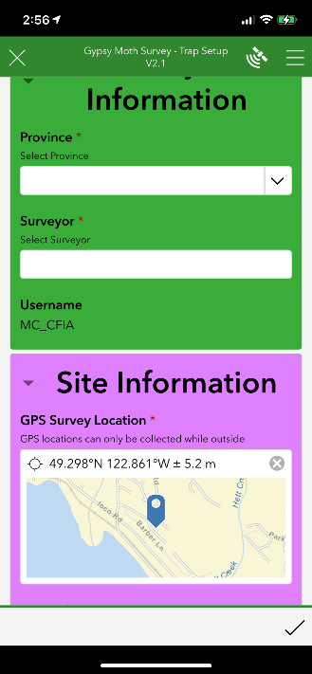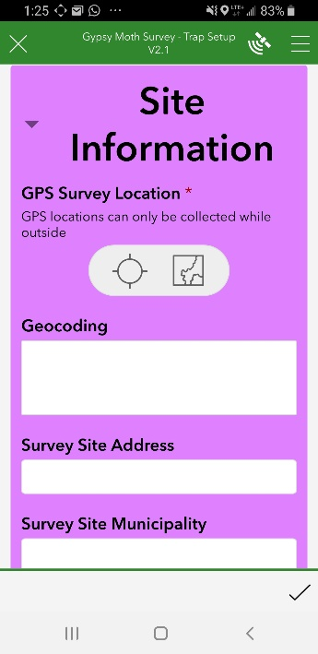
1&2.
1&2.

Mapping Icon

- Instead of selecting the crosshairs icon, select the “large map” or small “map” icons in the survey form to calculate the GPS for the survey site.
- Using this method requires the surveyor to have accurate knowledge of their location. This feature is most useful when the GPS is inaccurate.
- Use the “4 square” icon to open options for the basemap. Click your preferred base map by choosing from several types of maps e.g. Imagery, topography and street. “Imagery” basemap will likely be the most helpful as the map is quite detailed.
- Use the “ + ” and “ – “ icons to zoom in to your current location.
- Touch and move the screen to place the blue pin indicating the survey site location.
- Select the “check mark” to save the location into the Survey123 form.
- Selecting the mapping icon will also calculate the Geocoding field for the site address.

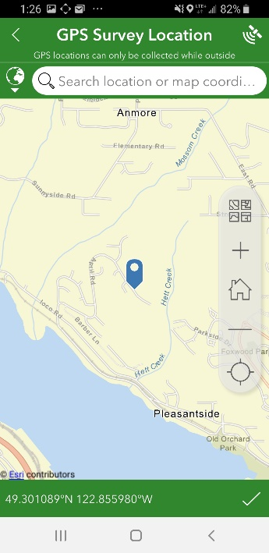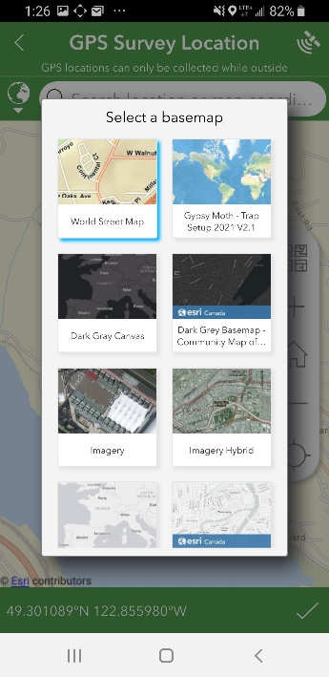

2.
2-5.
1.
1.

  - Inaccurate GPS capturing and the Webmap

If you are using Workforce for trap checks you should not be re-capturing the GPS in trap check forms (unless the trap setup location was inaccurate). If you are not using Workforce for trap checks (i.e. only Survey123) you need to ensure you accurately capture the GPS. Below is an image depicting single traps with many checks (orange circles) where the GPS was inaccurately captured. In the Webmap check points for a single trap should all stack on top of each other across the survey season.

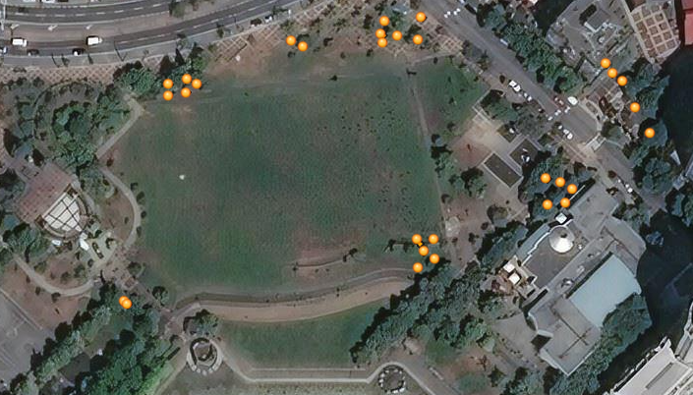

- Trap Check Status and Trap Condition Status
The trap check status and trap condition status options are an important way to track what has happened to a trap since it was last serviced and what you choose to do with the trap in the field at that particular check. Each option has specific steps that must be followed. Understanding these options is important as they have implications for how the data is collected, entered into LSTS and for future trap checks.

  - Trap Check Status Options:

- Okay – trap is in working order, all parts are present. Could include traps that have fallen to the ground and are not damaged. Trap check result – suspect, negative, N/A.

- Missing – Entire trap is gone. Trap check result – N/A.

- Damaged - lure missing, trap is vandalized (trash, needles, cable ties cut), trap has fallen/is on the ground and some part is broken or missing. Trap result – suspect, negative or N/A depending on what part of trap damaged. Please use the notes section to detail how trap was damaged.

- Poor Location - on highway/no safe place to pull over, blackberry growth, stinging nettle, dogs, bears, home owner request to relocate trap. Trap result – suspect, negative or N/A.

**** Note: Not applicable (N/A) means that you could not determine a trap result as either suspect or negative. This could be due to the trap being missing or damaged.

Trap With No Issues. i.e. Trap Check Condition Status: OK

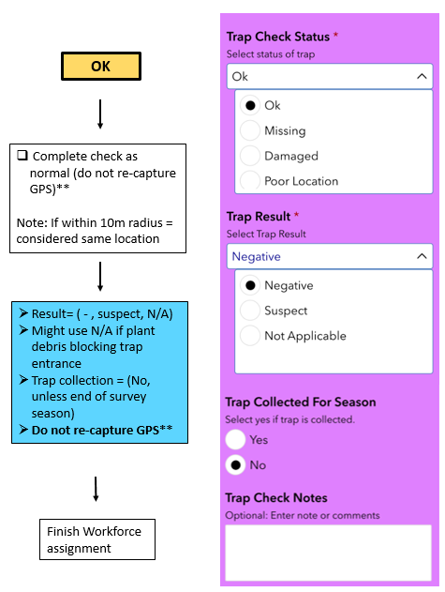

** If trap is not located near the original set up location i.e. trap set up GPS is inaccurate, re-capture the GPS location by selecting the “cross-hairs.

*** Note: When the pull down options “Missing”, “Damaged” and “Poor location” are chosen an additional drop down menu called “Trap Check Status” will appear.
  - Trap Condition Status Options:

- Replaced – traps that are replaced within 10m of original setup location.

- Finish the Survey123 check form for the trap you are working on.
    - Result = (Negative, Suspect, N/A).
    - Trap collection = (No, unless end of survey season).
    - Do not re-capture GPS.
    - Keep the same barcode for the trap, write the full barcode on the yellow. CFIA label if the barcode is missing.

- Finish the trap check assignment in Workforce.
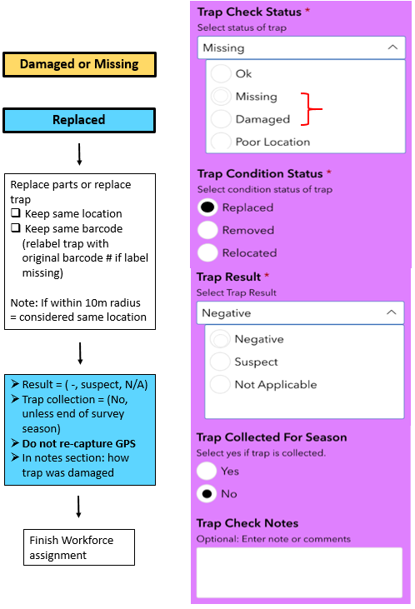

- Removed – traps are removed from the field completely e.g. theft, unsafe location etc.

- Finish the Survey123 check form for the trap you are working on.
    - Result = (Negative, Suspect, N/A).
    - Trap collection = (Yes, even if not end of survey season).
    - Do not re-capture GPS.
    - Remove the trap from the field, ensure the old barcode is removed and destroyed to prevent reuse.

- Finish the trap check assignment in Workforce.
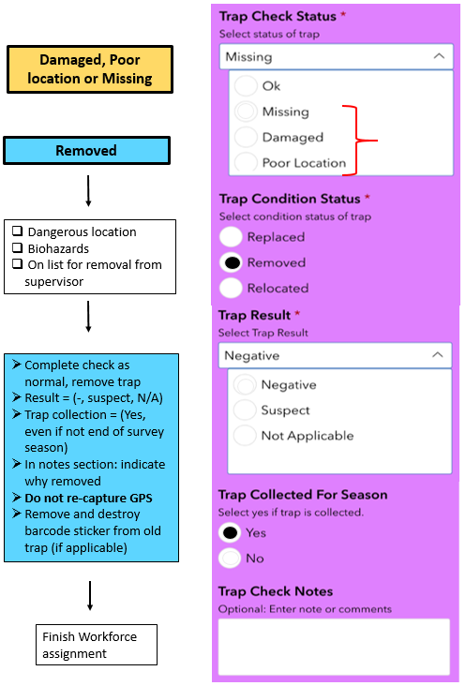
- Relocated – traps that are moved >10m from original setup location.

- Finish the Survey123 check form for the trap you are working on.
  - Result = (Negative, Suspect, N/A).
  - Trap collection = (Yes, even if not end of survey season).
  - Do not re-capture GPS.
  - Remove the trap from the field, destroy old barcode on trap.

- Finish the trap check assignment in Workforce.

- Lastly complete a NEW trap set up form for the survey. You do not need a Workforce assignment to start a new trap setup.
- Open Survey123 Trap Setup form and select “collect”.
- Chose a new trap location and capture all new trap set up information.
- Use a new barcode label.
- Capture a new GPS location.

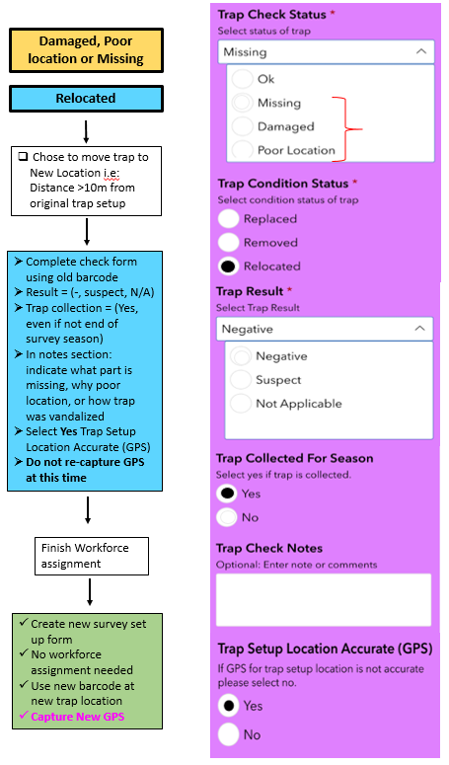
- Finding a Suspect
  - Key Steps to follow
- Confirm the barcode on the trap matches the Trap Barcode displayed at the top of the form.
  - Remember if you open a Workforce assignment and use “Survey at Assignment” for a trap that is not the one you are actually checking, the data will show up in the wrong location on the Webmap viewer. This is because Workforce prepopulates the setup location into the trap check form.
- In the notes section of the form include the number of suspects and whether the suspects are alive or dead.
- Include photos of the suspect(s).
1.
*** Note: It is CRITICAL when you find a suspect to verify that the barcode on the trap matches the Trap Barcode displayed at the top of the form.

